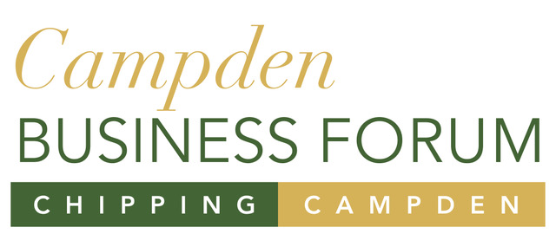

CDC latest updates on new funds, guidance for retailers and introducing 'Cotswold Taste'

COVID-19: business update 28 May

From Cllr Mike Evemy, Deputy Leader and Cabinet Member for Finance.
The Local Authority Discretionary Fund will open for applications in the Cotswold District on Monday 1 June for a two week period, closing on Sunday 14 June.
Applications will be assessed during the week commencing Monday 15 June with payments starting during the week commencing Monday 22 June.
In line with government guidance, the fund will prioritise the following types of businesses:
- Small businesses in shared offices or other flexible workspaces, who do not have their own Business Rates assessment
- Regular market traders with fixed building costs, such as rent, who do not have their own Business Rates assessment
- Bed & Breakfasts which pay Council Tax instead of Business Rates
- Charity properties in receipt of Charitable Business Rates Relief which would otherwise have been eligible for Small Business Rates Relief or Rural Rate Relief
In addition, Cotswold District Council is using its local discretion to include 'Businesses that supply goods or services to retail, hospitality and leisure businesses'.
You can apply for a discretionary grant from Cotswold District Council if your business:
- Is based in the Cotswold District
- Has suffered a significant fall in income due to the COVID-19 crisis
- Has relatively high ongoing fixed property-related costs
- Is not eligible for any other support schemes. This excludes the job retention scheme (Furlough) and the Self Employment Income Support Scheme
Businesses will not be eligible if:
- They were not trading on 11 March 2020,
- They are in administration, insolvent or had a striking-off notice issued,
- Their business property costs (i.e. Rateable Value, Annual Rent or Annual Mortgage costs) are above £51,000,
- They are eligible for other Covid-19 related grants (e.g. Small Business or Retail, Hospitality and Leisure grants),
- The receipt of a grant would take them over the State Aid limit
Applications will be made by filling in an online form which will be live on our website on Monday.

Full details of the government's business grant funds

Re-opening of retail businesses
All non-essential retail including shops selling clothes, shoes, toys, furniture, books, and electronics, plus tailors, auction houses, photography studios, and indoor markets, will be expected to be able to reopen from 15 June if the government’s five tests are met and they follow the COVID-19 secure guidelines.
The government has published comprehensive guidance to help business owners, managers and staff prepare. Do please take time to go through the guidance so you can prepare to open your business safely.

Guidance for working in or running a retail businesses

New fund for green start-ups
A new government backed £40 million Clean Growth Fund has been launched to help green start-ups. The fund will contribute towards the UK’s plans to reach Net Zero by 2050 and is available to UK-based companies driving green technology across the power, transport, waste, and building energy efficiency sectors.

Clean Growth Fund

Webinars to help businesses open safely
The government is running a series of webinars to supplement the guidance on how to open and run different types of business safely. Many businesses operate more than one type of workplace, such as an office, factory and fleet of vehicles and should therefore review the guidance for all appropriate workplaces.
Please note that if you miss the live sessions, recordings of the webinars will be available on BEIS Business Support YouTube page.

Working safely webinars

Cotswold food and drink producers go direct
Direct sales to the public are helping food and drink producers to stay in business and enabling customers to stock up on a few of their favourite things during lockdown. Several members of Cotswold Taste are reporting increased interest in home deliveries since the outbreak of Coronavirus. Some have set up online shops to reach customers who usually buy through high street stores and markets, while those with pre-existing digital outlets are reporting a surge in sales.
Cotswold Taste is a member-owned, not for profit co-operative that provides vital advice, business, marketing and promotional support to its members, food chain producers and support businesses to help their resilience and business success.

Find out more about Cotswold Taste

Other helpful organisations
Here is a selection of groups offering expert help and advice for businesses, but do also check the trade association for your own sector.
- Enterprise Nation - a vibrant community of small businesses and business advisers with a website packed full of resources
- Federation of Small Businesses (FSB) - the UK’s largest grassroots business campaigning group
- Institute of Directors (IoD) - business organisation for company directors
- Association of Independent Professionals and the Self-Employed (IPSE) - represents the UK's self-employed including freelancers, interim managers, consultants and contractors
- UK Hospitality - represents the broad hospitality sector – covering everything from bars, coffee shops, contract catering, hotels, nightclubs, visitor attractions and other leisure venues
- Gloucestershire Local Enterprise Partnership (GFirstLEP) - Growth hub for Gloucestershire

Summary of business support
The government's business support website sets out the full range of business support measures that have been made available to UK businesses and employees.

Government business support website

Keeping up to date
Please forward this email to others who might find this useful and encourage them to sign up to further updates.You can access previous editions of this newsletter too.

Sign up for this newsletter and see previous editions

COVID-19 Latest information and advice
Our council Coronavirus web pages have updates about business support, communities and leisure, bins and recycling, elections and council meetings, planning, building and council news.

Visit our website

